**Practical 03 Configure VLAN and Perform Inter VLAN Routing in Packet Tracer.**

**Step-1: Take Multilayer switch and connect devices to switch as shown below.**

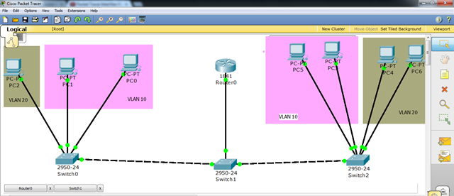

**Step-2: Click on Switch -> Go to CLI and enter configuration commands as shown here.**

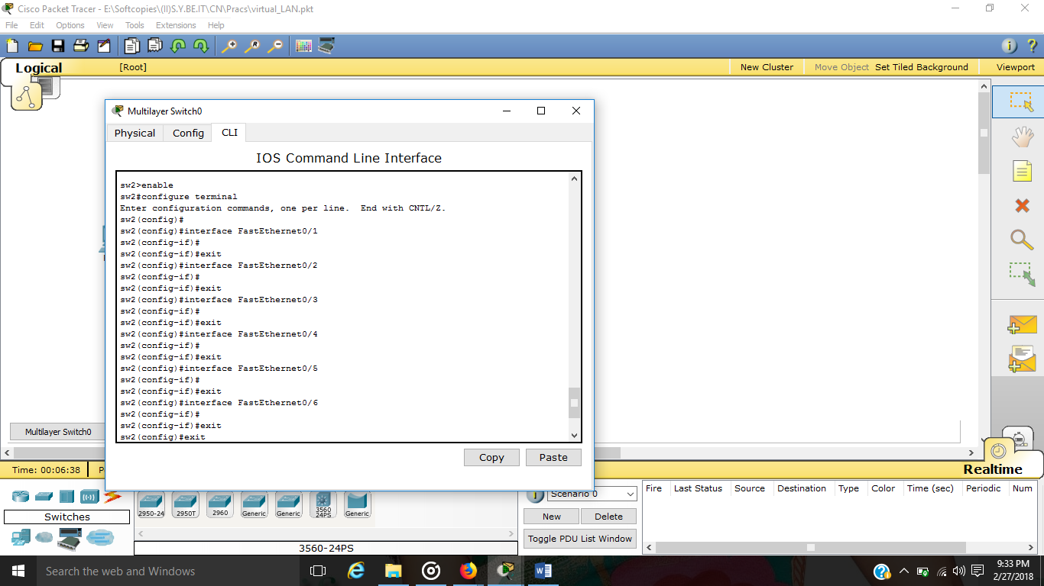

**Step-3: Configure IP address ,subnet mask and default gateway for each device as shown below.**

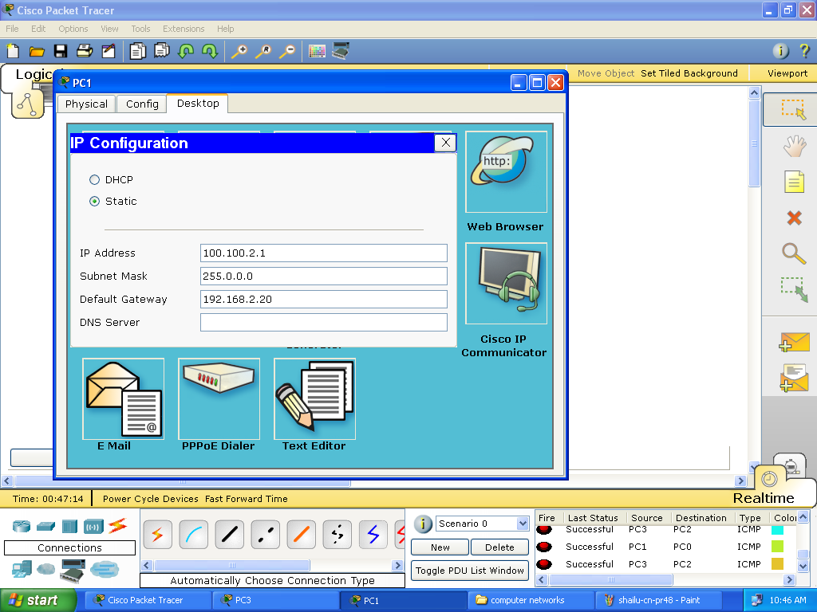

**Step-4: Open Command Prompt -> Apply ping command and the result would be as given below.**

